 | Experiment Title: Install VirtualBox/VMware Workstation on different OS.
 | Laboratory: CLOUD COUMPUTING LAB
Experiment No: 1 | Department: | Semester:

What is a VirtualBox?
VirtualBox is a software that enables you to install and operate different operating systems on your current operating system using the virtual machine concept. In other words, VirtualBox lets you create a virtual machine, which is like having a separate computer running within your main computer.
With VirtualBox, you can install and run different operating systems like Windows, Linux, and MacOS, all within their own separate virtual machines. This means that you can run multiple operating systems and applications on a single computer, without having to buy multiple machines or set up complex dual-boot configurations.
VirtualBox is a free and open-source software meaning that the source code is freely available for anyone to use, modify, and distribute. One of the great things about VirtualBox is that it allows you to take snapshots of your virtual machines, which means that you can save a “snapshot” of your virtual machine at a specific point in time. This allows you to easily restore your virtual machine to that specific state if something goes wrong.
VirtualBox also supports a variety of features like virtual networking, which allows your virtual machines to communicate with each other and with your main computer. It also supports USB pass through, which allows you to connect USB devices to your virtual machines.
Installation of Virtual Box
Steps to Install the Virtual Machine

- Search Virtual Box website: Go to https://www.virtualbox.org/wiki/Downloads in your computer’s browser. This is the website from which you’ll download the Virtual Box setup file.

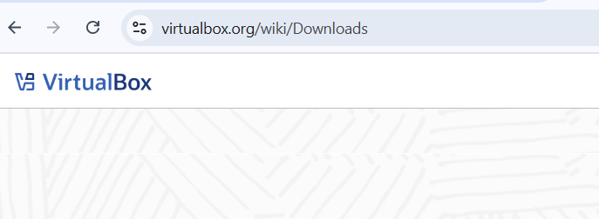
Figure 1 Search Virtual Box website.

- Click Windows hosts: You’ll see this link below the “Virtual Box 7.1.6 platform packages” heading. The Virtual Box EXE file will begin downloading onto your computer.

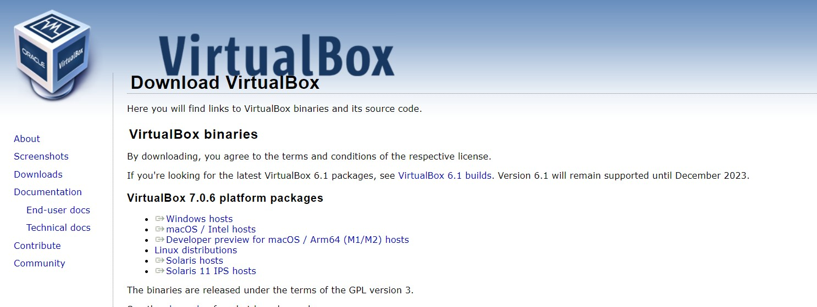
Figure 2 Click Windows hosts
- Open the Virtual Box EXE file: Go to the location to which the EXE file downloaded and double-click the file. Doing so will open the Virtual Box installation window.
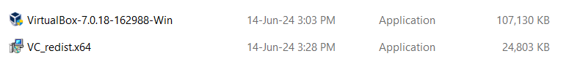
Figure 3 Open the Virtual Box EXE file
- Navigate through the installation prompts: Do the following:
  - Click Next on the first three pages.
  - Click Yes when prompted.
  - Click Install
  - Click Yes when prompted.

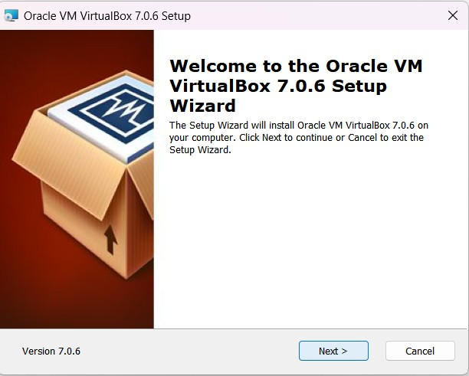
Figure 4 Navigate through the installation prompts.

Click on Install Computer when prompted: Doing so will allow Virtual Box to begin installing on your Computer.
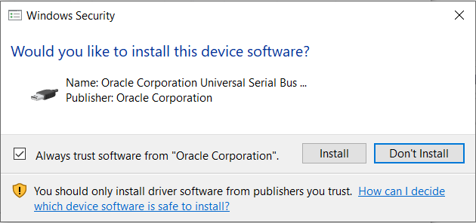
Figure 5 Click Install Computer when prompted
- Click on Finish Button: It's in the lower-right side of the window. Doing so will close the installation window and open Virtual Box. Now that you've installed and opened Virtual Box, you can create a virtual machine in order to run any operating system on your PC.
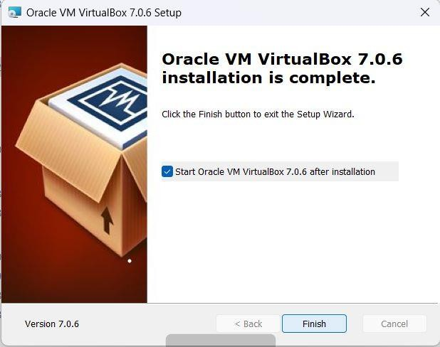
Figure 6 Click on Finish Button

- When you will open virtualbox it will look like as shown below

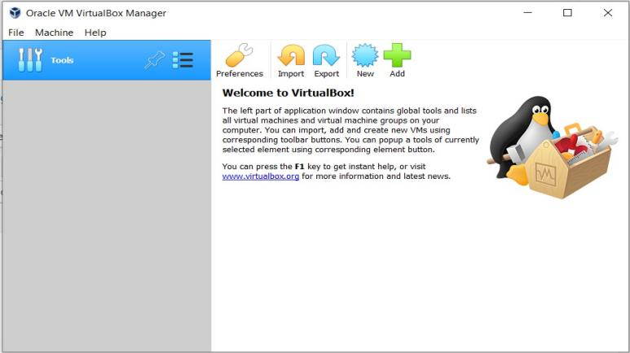
Figure 7 Installed Virtual Box

 | Experiment Title: Install different operating systems in VMware.
 | Laboratory: CLOUD COUMPUTING LAB
Experiment No: 2 | Department: | Semester:
Intallation of Operating System on Virtual Box
Procedure: We are going to install kali linux in our virtual machine.

Step1: Download Kali Linux ISO Image
On the official Kali Linux website downloads section, you can find Kali Linux Iso images.
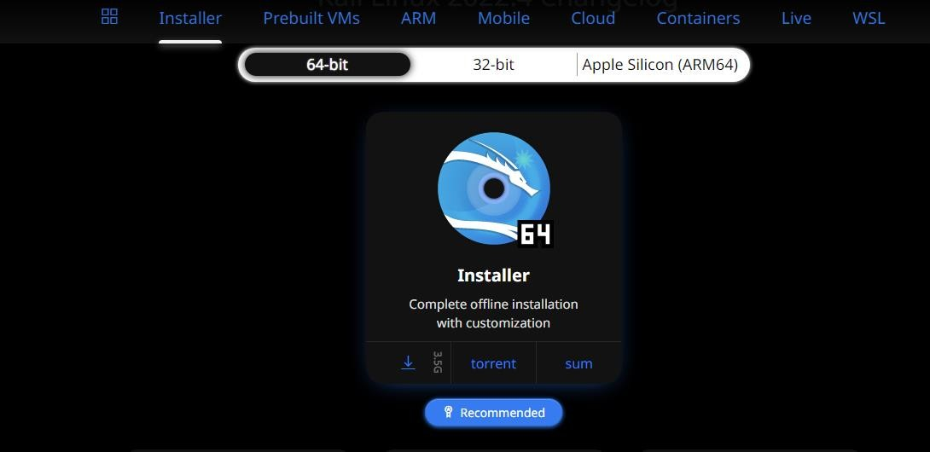
- Navigate to the Kali Linux Downloads page and find the packages available for download. Depending on the system you have, download the 64-Bit or 32-Bit version.
Figure 1 Download Kali Linux ISO Image
Step 2: Create Kali Linux Virtual Box
After downloading the .iso image, create a new virtual machine and import Kali as its OS.
- Launch Virtual Box Manager and click the New icon.
- Name and operating system. A pop-up window for creating a new VM appears. Specify a name and
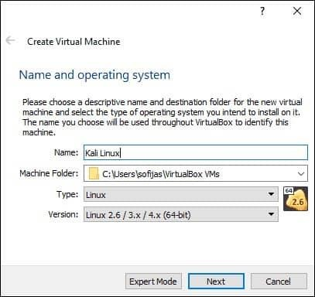
Destination folder. And click next.
Figure 2 Create Kali Linux Virtual Box Container
3 Memory size: Choose how much memory to allocate to the virtual machine and click Next. The default setting for Linux is 1 GB.

4 Hard disk.: The default option is to create a virtual hard disk for the new VM. Click Create to continue.
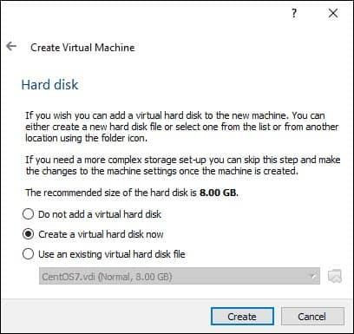
Figure 3
5 Hard disk file type. Stick to the default file type for the new virtual hard disk, VDI (Virtual Box Disk Image). Click Next to continue.

6 Storage on a physical hard disk. Decide between Dynamically allocated and Fixed size. The first choice allows the new hard disk to grow and fill up space dedicated to it. The second, fixed size, uses the maximum capacity from the start. Click Next.

7 File location and size. Specify the name and where you want to store the virtual hard disk. Choose the amount of file data the VM is allowed to store on the hard disk. Click Create to finish.

Now you created a new VM. The VM appears on the list in the VirtualBox Manager.

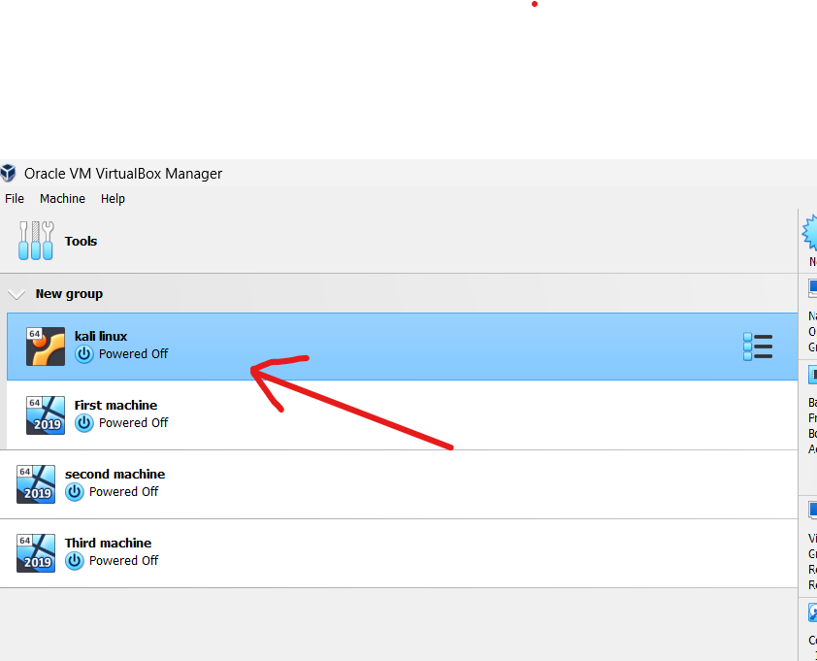
Figure 4 Installed Os

Step 3: Configure Virtual Machine Settings

The next step is adjusting the default virtual machine settings.

- Select a virtual machine and click the Settings icon. Make sure you marked the correct VM and that the right-hand side is displaying details for Kali Linux.
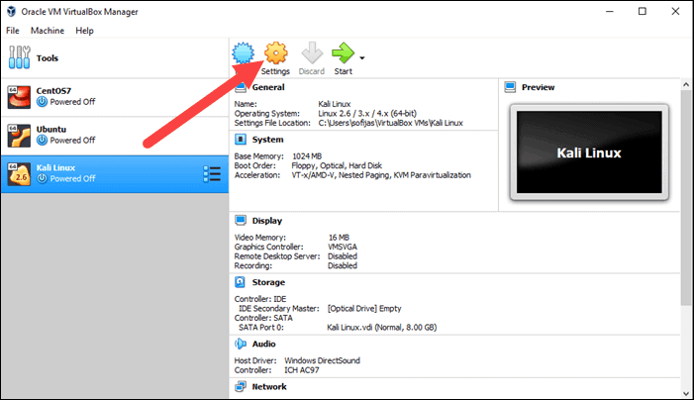
Figure 5 Setting Up Installed OS
- In the Kali Linux – Settings window, navigate to General > Advanced tab. Change the Shared
Clipboard and Drag ’‘n’ Drop settings to Bidirectional. This feature allows you to copy and paste
between the host and guest machine.
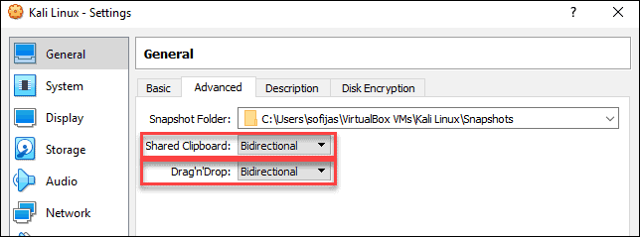
Figure 6 General Setting
- Go to System > Motherboard. Set the boot order to start from Optical, followed by Hard Disk. Uncheck Floppy as it is unnecessary.
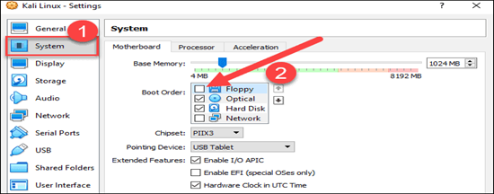
Figure 7 Memory Allocation
- Next, move to the Processor tab in the same window. Increase the number of processors to two (2) to enhance performance.
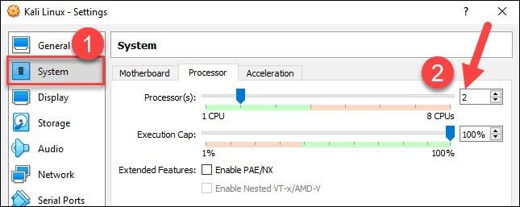
Figure 8 Processor Set up
- Finally, navigate to Storage settings. Add the downloaded Kali image to a storage device under Controller: IDE. Click the disk icon to search for the image. Once finished, close the Settings window.
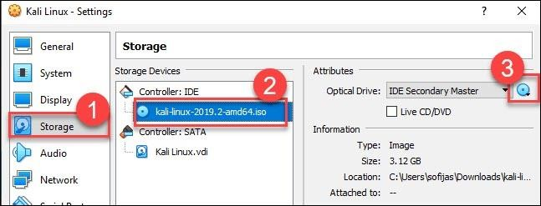
- Click the Start icon to begin installing Kali.
Figure 9 Storage
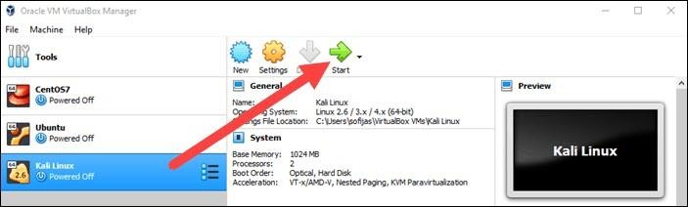
Figure 10 Stating the installation process

Step 4: Installing and Setting Up Kali Linux

After you booted the installation menu by clicking Start, a new VM Virtual Box window appears with the Kali welcome screen.
Select the Graphical install option and go through the following installation steps for setting up Kali Linux in Virtual Box.
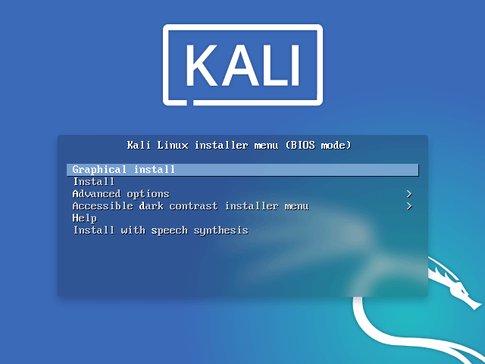
Figure 11 Configuring Kali Linux
- Select a language. Choose the default language for the system.
- Select your location. Find and select your country.
- Configure the keyboard. Decide which key map to use. In most cases, the best option is to select American English.
- Configure the network. First, enter a hostname for the system and click Continue.
- Next, create a domain name (the part of your internet address after your hostname). Domain names usually end in .com, .net, .edu, etc. Make sure you use the same domain name on all your machines.
- Set up users and passwords. Create a strong password for the administrator account.
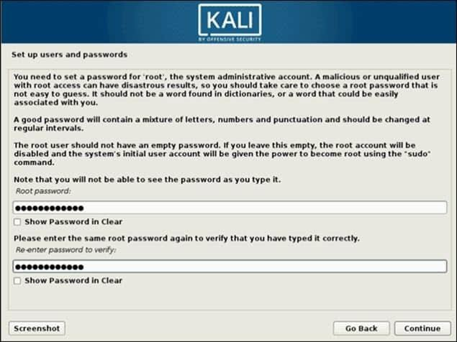
Figure 12 Set up Password
- Configure the clock. Select your time zone from the available options.
- Partition disks. Select how you would like to partition the hard disk. Unless you have a good reason to do it manually, go for the Guided –use entire disk option.
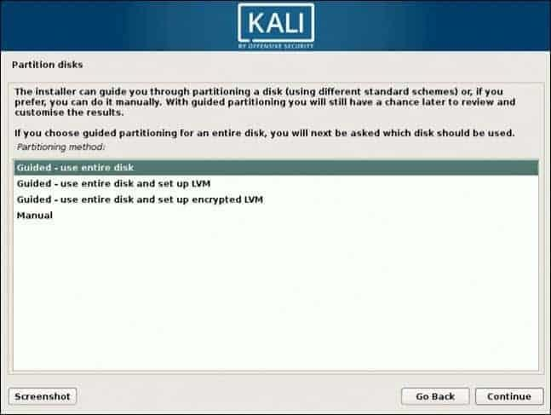
Figure 13 Disk Partition
- Then, select which disk you want to use for partitioning. As you created a single virtual hard disk in Step3
- Next, select the scheme for partitioning. If you are a new user, go for All files in one partition.
- The wizard gives you an overview of the configured partitions. Continue by navigating to Finish partitioning and write changes to disk. Click Continue and confirm with Yes.
- The wizard starts installing Kali. While the installation bar loads, additional configuration settings appear.
- Configure the package manager. Select whether you want to use a network mirror and click Continue.
Enter the HTTP proxy information if you are using one. Otherwise, leave the field blank and click Continue again.
- Install the GRUB boot loader on a hard disk. Select Yes and Continue. Then, select a boot loader
device to ensure the newly installed system is bootable.
- Once you receive the message Installation is complete, click Continue to reboot your VM.
With this, you have successfully installed Kali Linux on Virtual Box. After rebooting, the Kali login screen appears. Type in a username and password you entered in the previous steps.

Finally, the interface of Kali Linux appears on your screen.

Figure 14 Installed Kali Linux
 | Experiment Title: Simulate a cloud scenario using simulator.
 | Laboratory: CLOUD COUMPUTING LAB
Experiment No: 3 | Department: | Semester:

What is CloudSim?
Cloud Computing is one of the hottest topics in town. It has completely transformed how modern-day applications are developed and maintained with high scalability and low latency.
CloudSim is an open-source framework, which is used to simulate cloud computing infrastructure and services. It is developed by the CLOUDS Lab organization and is written entirely in Java. It is used for modelling and simulating a cloud computing environment as a means for evaluating a hypothesis prior to software development in order to reproduce tests and results.
For example, if you were to deploy an application or a website on the cloud and wanted to test the services and load that your product can handle and also tune its performance to overcome bottlenecks before risking deployment, then such evaluations could be performed by simply coding a simulation of that environment with the help of various flexible and scalable classes provided by the CloudSim package, free of cost.

CloudSim Architecture:

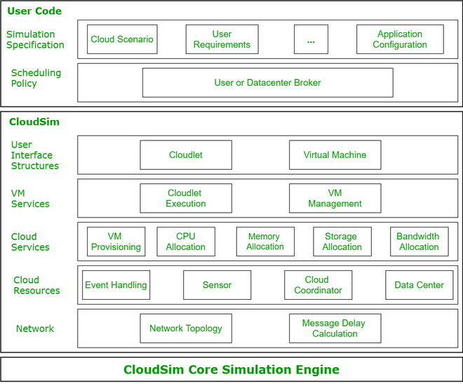

Figure 1 CloudSim Architecture
PROCEDURE:
- Download Java, Eclipse IDE and install it.
- Download Cloudsim jar Files
- Create a new java project and add Cloudsim jar files

Step 1: From the zip folder extracts cloudsim-3.0.3 into a folder. Also, extract the commons-math3-3.6.1 jar into the same folder.
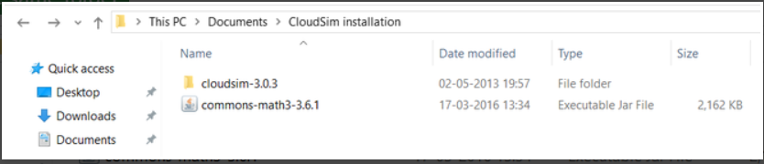
Figure 2 Extract files
Step 2: Open Eclipse IDE and go to File -> New -> Java Project.
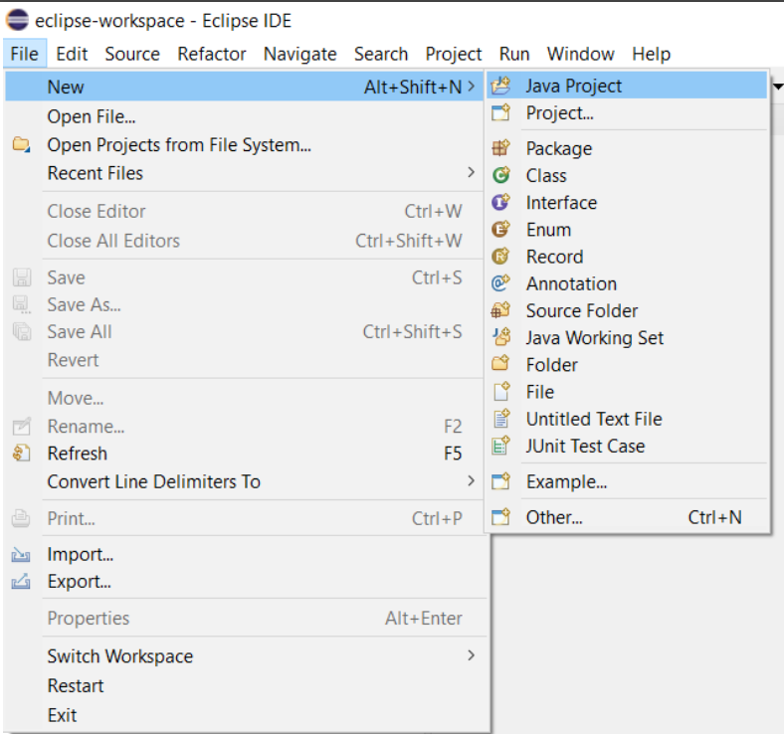
Figure 3 Make File
Step 3: Enter any name for your project and then uncheck the Use default location box just under it and click on Browse.
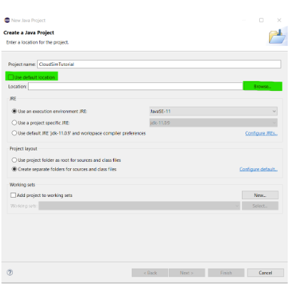
Figure 4 Create file
Browse to the folder where you extracted your files and select the cloudsim-3.0.3 folder.
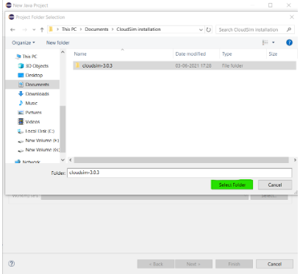
Figure 5 Extracted file
Step 4: Click Next and go to Libraries -> Add External JARs. Now browse to the same folder where you extracted your commons-math3 jar file and Open it.

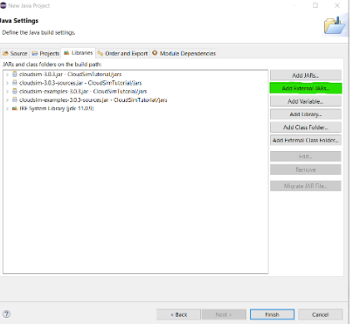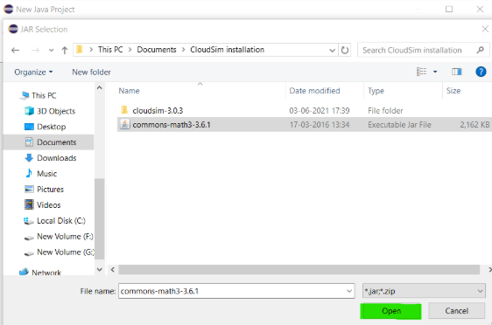
Figure 6 Add External JAR’s
Step 5 Finally click on Finish and wait for the project to build. After the project has been built, from the Project Explorer you can click on your project and from the dropdown go-to examples -> org.cloudbus.cloudsim.examples where you can find pre-written sample codes and try to run them.
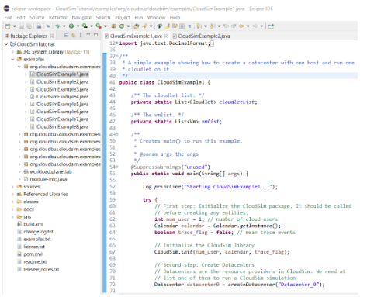
Figure 7 Setup
Now Creating Datacenters, Virtual Machines, And Cloudlets In The CloudSim Environment And Checking Its Output.

Step 1: We open CloudSimExample2.java from the library on the left and create a data center first.

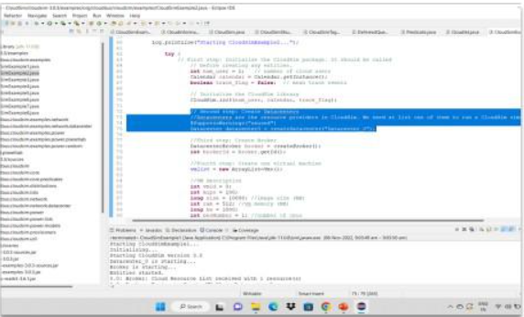
Figure 1 Creating a datacenter in CloudSim
Step 2: The initial configuration of one of VM(Virtual machine) is done i.e mips(million instructions), ram(size of RAM), bw(bandwidth), etc. Here we create 4 VMs which are initialized with different configuration and added to vmlist, which is the array list created to store all the 4VMs.
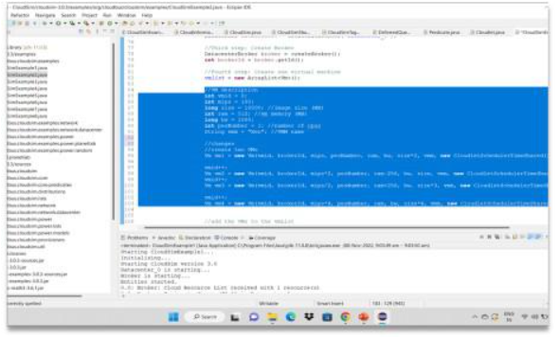
Figure 2 Configuring Virtual Machine
Step 3: We create 8 cloudlets that are initialized with different properties or characteristics i.e id length, outputsize, and filesize.

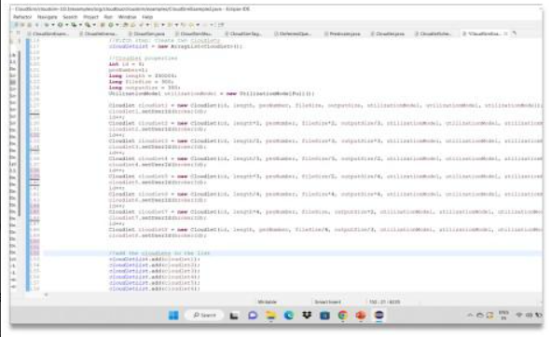
Figure 3 Creating Cloudlets With Different Characteristics

Step 4: Now the VM-cloudlet binding is done using the broker.
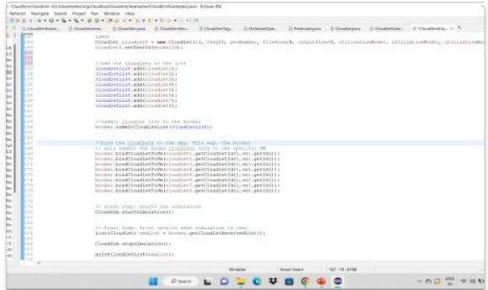
Figure 4 VM-Cloudlet Binding
Below is the code for the above implementation of steps:
import java.text.DecimalFormat;
import java.util.ArrayList;
import java.util.Calendar;
import java.util.LinkedList;
import java.util.List;
import org.cloudbus.cloudsim.Cloudlet;
import org.cloudbus.cloudsim.CloudletSchedulerTimeShared;
import org.cloudbus.cloudsim.Datacenter;
import org.cloudbus.cloudsim.DatacenterBroker;
import org.cloudbus.cloudsim.DatacenterCharacteristics;
import org.cloudbus.cloudsim.Host;
import org.cloudbus.cloudsim.Log;
import org.cloudbus.cloudsim.Pe;
import org.cloudbus.cloudsim.Storage;
import org.cloudbus.cloudsim.UtilizationModel;
import org.cloudbus.cloudsim.UtilizationModelFull;
import org.cloudbus.cloudsim.Vm;
import org.cloudbus.cloudsim.VmAllocationPolicySimple;
import org.cloudbus.cloudsim.VmSchedulerTimeShared;
import org.cloudbus.cloudsim.core.CloudSim;
import org.cloudbus.cloudsim.provisioners.BwProvisionerSimple;
import org.cloudbus.cloudsim.provisioners.PeProvisionerSimple;
import org.cloudbus.cloudsim.provisioners.RamProvisionerSimple;
// A simple example showing how to create a data center
// with one host and run eight cloudlets on it
public class CloudSimExample1 {
// The cloudlet list
private static List<Cloudlet> cloudletList;
// The vmlist
private static List<Vm> vmlist;
@SuppressWarnings("unused")
public static void main(String[] args)
{
Log.printLine("Starting CloudSimExample2...");

try {
// First step: Initialize the CloudSim package.
// It should be called before creating any
// entities. number of cloud users
int num_user = 1;
// Calendar whose fields have been initialized
// with the current date and time.
Calendar calendar = Calendar.getInstance();
// trace events
boolean trace_flag = false;

CloudSim.init(num_user, calendar, trace_flag);

// Second step: Create Datacenters
// Datacenters are the resource providers in
// CloudSim. We need at list one of them to run
// a CloudSim simulation
Datacenter datacenter0
= createDatacenter("Datacenter_0");

// Third step: Create Broker
DatacenterBroker broker = createBroker();
int brokerId = broker.getId();
// Fourth step: Create four virtual machine
vmlist = new ArrayList<Vm>();
// VM description
int vmid = 0;
int mips = 1000;
long size = 10000; // image size (MB)
int ram = 512; // vm memory (MB)
long bw = 1000; // bandwidth
int pesNumber = 1; // number of cpus
String vmm = "Xen"; // VMM name

// create 4 VMs
Vm vm1
= new Vm(vmid, brokerId, mips, pesNumber,
ram, bw, size, vmm,
new CloudletSchedulerTimeShared());
vmid++;
Vm vm2 = new Vm(
vmid, brokerId, mips * 2, pesNumber,
ram - 256, bw, size * 2, vmm,
new CloudletSchedulerTimeShared());
vmid++;
Vm vm3 = new Vm(
vmid, brokerId, mips / 2, pesNumber,
ram + 256, bw, size * 3, vmm,
new CloudletSchedulerTimeShared());
vmid++;
Vm vm 4
= new Vm(vmid, brokerId, mips * 4,
pesNumber, ram, bw, size * 4, vmm,
new CloudletSchedulerTimeShared());
vmid++;
// add the VM to the vmList
vmlist.add(vm1);
vmlist.add(vm2);
vmlist.add(vm3);
vmlist.add(vm4);
// submit vm list to the broker
broker.submitVmList(vmlist);
// Fifth step: Create eight Cloudlets
cloudletList = new ArrayList<Cloudlet>();
// Cloudlet properties
int id = 0;
long length = 400000;
long fileSize = 300;
long outputSize = 300;
UtilizationModel utilizationModel
= new UtilizationModelFull();

Cloudlet cloudlet1 = new Cloudlet(
id, length, pesNumber, fileSize, outputSize,
utilizationModel, utilizationModel,
utilizationModel);
cloudlet1.setUserId(brokerId);
id++;
Cloudlet cloudlet2 = new Cloudlet(
id, length * 2, pesNumber, fileSize * 2,
outputSize / 3, utilizationModel,
utilizationModel, utilizationModel);
cloudlet2.setUserId(brokerId);
id++;
Cloudlet cloudlet3 = new Cloudlet(
id, length / 2, pesNumber, fileSize * 3,
outputSize * 3, utilizationModel,
utilizationModel, utilizationModel);
cloudlet3.setUserId(brokerId);
Cloudlet cloudlet4 = new Cloudlet(
id, length / 3, pesNumber, fileSize / 3,
outputSize / 2, utilizationModel,
utilizationModel, utilizationModel);
cloudlet4.setUserId(brokerId);
Cloudlet cloudlet5 = new Cloudlet(
id, length * 3, pesNumber, fileSize / 2,
outputSize / 4, utilizationModel,
utilizationModel, utilizationModel);
cloudlet5.setUserId(brokerId);
Cloudlet cloudlet6 = new Cloudlet(
id, length / 4, pesNumber, fileSize * 4,
outputSize * 4, utilizationModel,
utilizationModel, utilizationModel);
cloudlet6.setUserId(brokerId);
Cloudlet cloudlet7 = new Cloudlet(
id, length * 4, pesNumber, fileSize,
outputSize * 2, utilizationModel,
utilizationModel, utilizationModel);
cloudlet7.setUserId(brokerId);
Cloudlet cloudlet8 = new Cloudlet(
id, length, pesNumber, fileSize / 4,
outputSize / 3, utilizationModel,
utilizationModel, utilizationModel);
cloudlet8.setUserId(brokerId);
// add the cloudlet to the list
cloudletList.add(cloudlet1);
cloudletList.add(cloudlet2);
cloudletList.add(cloudlet3);
cloudletList.add(cloudlet4);
cloudletList.add(cloudlet5);
cloudletList.add(cloudlet6);
cloudletList.add(cloudlet7);
cloudletList.add(cloudlet8);
// submit cloudlet list to the broker
broker.submitCloudletList(cloudletList);
// bind the cloudlets to the vms,This way the
// broker will submit the bound cloudlets only
// to the specific VM
broker.bindCloudletToVm(
Cloudlet1.getCloudletId(), vm1.getId());
broker.bindCloudletToVm(
Cloudlet2.getCloudletId(), vm2.getId());
broker.bindCloudletToVm(
Cloudlet3.getCloudletId(), vm3.getId());
broker.bindCloudletToVm(
Cloudlet4.getCloudletId(), vm4.getId());
broker.bindCloudletToVm(
Cloudlet5.getCloudletId(), vm1.getId());
broker.bindCloudletToVm(
Cloudlet6.getCloudletId(), vm2.getId());
broker.bindCloudletToVm(
Cloudlet7.getCloudletId(), vm3.getId());
broker.bindCloudletToVm(
Cloudlet8.getCloudletId(), vm4.getId());
// Sixth step: Starts the simulation
CloudSim.startSimulation();
CloudSim.stopSimulation();
// Final step: Print results when simulation is
// over
List<Cloudlet> newList
= broker.getCloudletReceivedList();
printCloudletList(newList);

Log.printLine("CloudSimExample1 finished!");
}
catch (Exception e) {
e.printStackTrace();
Log.printLine("Unwanted errors happen");
}
}
private static Datacenter createDatacenter(String name)
{
// Here are the steps needed to create a
// PowerDatacenter:
// 1. We need to create a list to store
// our machine
List<Host> hostList = new ArrayList<Host>();

// 2. A Machine contains one or more PEs or
// CPUs/Cores. In this example, it will have only
// one core.
List<Pe> peList = new ArrayList<Pe>();

int mips = 1000;

// 3. Create PEs and add these into a list.
// need to store Pe id and MIPS Rating
peList.add(
new Pe(0, new PeProvisionerSimple(mips)));

// 4. Create Host with its id and list of PEs and
// add them to the list of machines
int hostId = 0;
int ram = 2048; // host memory (MB)
long storage = 1000000; // host storage
int bw = 10000;
hostList.add(new Host(
hostId, new RamProvisionerSimple(ram),
new BwProvisionerSimple(bw), storage, peList,
new VmSchedulerTimeShared(
peList))); // This is our machine

// 5. Create a DatacenterCharacteristics object that
// stores the properties of a data center:
// architecture, OS, list of Machines, allocation
// policy: time- or space-shared, time zone and its
// price (G$/Pe time unit).
String arch = "x86"; // system architecture
String os = "Linux"; // operating system
String vmm = "Xen";
double time_zone
= 10.0; // time zone this resource located
double cost = 3.0; // the cost of using processing
// in this resource
double costPerMem = 0.05; // the cost of using
// memory in this resource
double costPerStorage
= 0.001; // the cost of using storage in this
// resource
double costPerBw
= 0.0; // the cost of using bw in this resource
LinkedList<Storage> storageList
= new LinkedList<Storage>(); // we are not
// adding SAN
// devices by now
DatacenterCharacteristics characteristics
= new DatacenterCharacteristics(
arch, os, vmm, hostList, time_zone, cost,
costPerMem, costPerStorage, costPerBw);

// 6. Finally, we need to create a PowerDatacenter
// object.
Datacenter datacenter = null;
try {
datacenter = new Datacenter(
name, characteristics,
new VmAllocationPolicySimple(hostList),
storageList, 0);
}
catch (Exception e) {
e.printStackTrace();
}

return datacenter;
}
private static DatacenterBroker createBroker()
{
DatacenterBroker broker = null;
try {
broker = new DatacenterBroker("Broker");
}
catch (Exception e) {
e.printStackTrace();
return null;
}
return broker;
}
private static void
printCloudletList(List<Cloudlet> list)
{
int size = list.size();
Cloudlet cloudlet;
String indent = " ";
Log.printLine();
Log.printLine("========== OUTPUT ==========");
Log.printLine("Cloudlet ID" + indent + "STATUS"
+ indent + "Data center ID" + indent
+ "VM ID" + indent + "Time" + indent
+ "Start Time" + indent
+ "Finish Time");

DecimalFormat dft = new DecimalFormat("###.##");
for (int i = 0; i < size; i++) {
cloudlet = list.get(i);
Log.print(indent + cloudlet.getCloudletId()
+ indent + indent);

if (cloudlet.getCloudletStatus()
== Cloudlet.SUCCESS) {
Log.print("SUCCESS");
Log.printLine(
indent + indent
+ cloudlet.getResourceId() + indent
+ indent + indent + cloudlet.getVmId()
+ indent + indent
+ dft.format(
cloudlet.getActualCPUTime())
+ indent + indent
+ dft.format(
cloudlet.getExecStartTime())
+ indent + indent
+ dft.format(cloudlet.getFinishTime()));
}
}
}
}

Step 5: Output after running the program is shown. One can see all the VM and cloudlets are created and their finish time(performance) is different as their VM and cloudlet configurations were different.

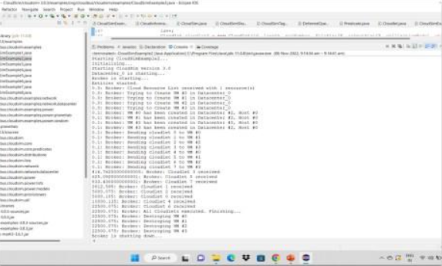
Figure 5

 | Experiment Title: Implement scheduling algorithms.
 | Laboratory: CLOUD COUMPUTING LAB
Experiment No: 4 | Department: | Semester:
Scheduling is a process of determining which process will own CPU for execution while another process is on hold. The main task of CPU scheduling is to make sure that whenever the CPU remains idle, the OS at least select one of the processes available in the ready queue for execution. The selection process will be carried out by the CPU scheduler. It selects one of the processes in memory that are ready for execution.
Different scheduling algorithms can be used depending on the type of the task to be scheduled. The scheduling algorithms can utilize better executing efficiency and maintain the load balancing of system.
The efficiency of the cloud depends on the algorithms used for task scheduling. Scheduling algorithm could be either a preemptive or non-preemptive type. In non-preemptive scheduling algorithm, no force can stop the execution of a task. On the other hand, a task execution could be stooped in the preemptive scheduling algorithm because of many factors. In order to evaluate scheduling algorithms efficiency, a set of criteria’s are needed including both of turnaround time and waiting time.
Some Important Terms that are used in these scheduling algorithms-
A.T= Arrival Time
B.T= Burst Time
C.T= Completion Time
T.T = Turnaround Time = Completion Time - Arrival Time = C.T - A.T
W.T = Waiting Time = Turnaround Time - Burst Time = T.T - B.T
First Come First Serve (FCFS) Scheduling Algorithm
First Come First Serve is the full form of FCFS. It is the easiest and most simple CPU scheduling algorithm. In this type of algorithm, the process which requests the CPU gets the CPU allocation first. This scheduling method can be managed with a FIFO queue.
As the process enters the ready queue, its PCB (Process Control Block) is linked with the tail of the queue. So, when CPU becomes free, it should be assigned to the process at the beginning of the queue.
- Jobs are executed on first come, first serve basis.
- It is a non-preemptive, pre-emptive scheduling algorithm.
- Easy to understand and implement.
- Its implementation is based on FIFO queue.
- Poor in performance as average wait time is high.
ALGORITHM:
Step 1: Start the process
Step 2: Accept the number of processes in the ready Queue
Step 3: For each process in the ready Q, assign the process name and the burst time
Step 4: Set the waiting of the first process as ̳0‘and its burst time as its turnaround time
Step 5: for each process in the Ready Q calculate a). Waiting time (n) = waiting time (n-1) +
Burst time (n-1) b). Turnaround time (n)= waiting time(n)+Burst time(n)
Step 6: Calculate a) Average waiting time = Total waiting Time / Number of process b)
Average Turnaround time = Total Turnaround Time / Number of process
Step 7: Stop the process
SOURCE CODE:
#include <iostream>
using namespace std;
// Function to calculate waiting time of each process
void findWaitingTime(int processes[], int n, int bt[], int wt[]) {
wt[0] = 0; // Waiting time for the first process is always 0

// Calculate waiting time for other processes
for (int i = 1; i < n; i++) {
wt[i] = bt[i - 1] + wt[i - 1];
}
}
// Function to calculate turnaround time of each process
void findTurnAroundTime(int processes[], int n, int bt[], int wt[], int tat[]) {
// Calculate turnaround time by adding burst time and waiting time
for (int i = 0; i < n; i++) {
tat[i] = bt[i] + wt[i];
}
}

// Function to calculate average waiting and turnaround times
void findAvgTime(int processes[], int n, int bt[]) {
int wt[n], tat[n]; // Arrays to store waiting time and turnaround time
int total_wt = 0, total_tat = 0;

// Function calls to calculate waiting and turnaround times
findWaitingTime(processes, n, bt, wt);
findTurnAroundTime(processes, n, bt, wt, tat);

// Display process details
cout << "Processes " << "Burst Time " << "Waiting Time " << "Turnaround Time\n";

for (int i = 0; i < n; i++) {
total_wt += wt[i];
total_tat += tat[i];
cout << " " << processes[i] << "\t\t" << bt[i] << "\t\t " << wt[i] << "\t\t " << tat[i] << endl;
}
// Display average waiting and turnaround times
cout << "Average waiting time = " << (float)total_wt / n << endl;
cout << "Average turnaround time = " << (float)total_tat / n << endl;
}
int main() {
int processes[] = {1, 2, 3}; // Process IDs
int n = sizeof(processes) / sizeof(processes[0]); // Number of processes
int burst_time[] = {23, 65, 18}; // Burst time for each process

findAvgTime(processes, n, burst_time); // Function call to calculate average times
return 0;
}
OUTPUT
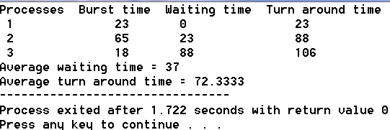
Shortest Job First (SJF) Scheduling Algorithm
SJF is a full form of (Shortest job first) is a scheduling algorithm in which the process with the shortest execution time should be selected for execution next. This scheduling method can be preemptive or non-preemptive. It significantly reduces the average waiting time for other processes awaiting execution.
- This is a non-preemptive, pre-emptive scheduling algorithm.
- Best approach to minimize waiting time.
- Easy to implement in Batch systems where required CPU time is known in advance.
- Impossible to implement in interactive systems where required CPU time is not known.
- The processer should know in advance how much time process will take.
ALGORITHM:
Step 1: Start the process
Step 2: Accept the number of processes in the ready Queue
Step 3: For each process in the ready Q, assign the process id and accept the CPU
burst time
Step 4: Start the Ready Q according the shortest Burst time by sorting according to
lowest to highest burst time.
Step 5: Set the waiting time of the first process as ̳0‘ and its turnaround time as its burst
time.
Step 6: Sort the processes names based on their Burt time
Step 7: For each process in the ready queue, calculate
- Waiting time(n)= waiting time (n-1) + Burst time (n-1)
- b) Turnaround time (n)= waiting time(n)+Burst time(n)
Step 8: Calculate
c) Average waiting time = Total waiting Time / Number of process
d)Average Turnaround time = Total Turnaround Time / Number of process
Step 9: Stop the process.

SOURCE CODE:
#include <iostream>
using namespace std;

int main() {
int A[100][4];
int i, j, n, total = 0, index, temp;
float avg_wt, avg_tat;

// Input the number of processes
cout << "Enter the number of processes: ";
cin >> n;

// Input the burst time for each process
cout << "Enter Burst Time:" << endl;
for (i = 0; i < n; i++) {
cout << "Process " << i + 1 << ": ";
cin >> A[i][1];
A[i][0] = i + 1; // Store process ID
}

// Sort processes by burst time (SJF Scheduling)
for (i = 0; i < n; i++) {
index = i;
for (j = i + 1; j < n; j++) {
if (A[j][1] < A[index][1]) {
index = j;
}
}
// Swap burst times
temp = A[i][1];
A[i][1] = A[index][1];
A[index][1] = temp;

// Swap process IDs
temp = A[i][0];
A[i][0] = A[index][0];
A[index][0] = temp;
}

// Calculate waiting time
A[0][2] = 0; // Waiting time for the first process is 0
for (i = 1; i < n; i++) {
A[i][2] = 0;
for (j = 0; j < i; j++) {
A[i][2] += A[j][1];
}
total += A[i][2];
}
avg_wt = (float)total / n; // Average waiting time
total = 0;

// Display results
cout << "\nProcess\tBurst Time\tWaiting Time\tTurnaround Time" << endl;
for (i = 0; i < n; i++) {
A[i][3] = A[i][1] + A[i][2]; // Turnaround time = Burst time + Waiting time
total += A[i][3];
cout << "P" << A[i][0] << "\t" << A[i][1] << "\t\t" << A[i][2] << "\t\t" << A[i][3] << endl;
}
avg_tat = (float)total / n; // Average turnaround time

// Display average waiting and turnaround times
cout << "\nAverage Waiting Time = " << avg_wt << endl;
cout << "Average Turnaround Time = " << avg_tat << endl;

return 0;
}
OUTPUT
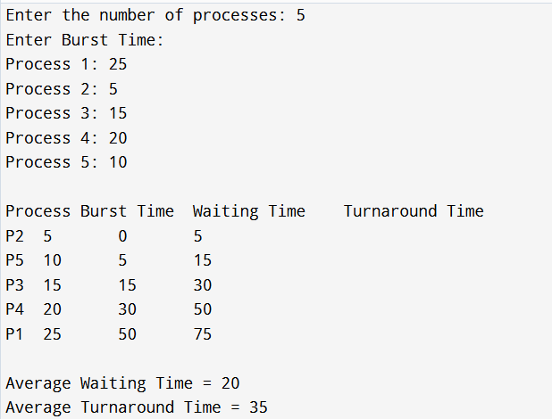

 | Experiment Title: To study cloud security management.
 | Laboratory: CLOUD COUMPUTING LAB
Experiment No: 5 | Department: | Semester:

What is cloud security?
Cloud security refers to the cybersecurity policies, best practices, controls, and technologies used to secure applications, data, and infrastructure in cloud environments. In particular, cloud security works to provide storage and network protection against internal and external threats, access management, data governance and compliance, and disaster recovery.

What is cloud security management?
Cloud security management refers to a set of strategies that work to protect data and applications in cloud services. The procedures include rules for access, technical controls, policies, and processes.
Cloud security relies on the model of shared responsibility. Here, the provider manages infrastructure while those working in service set up access across cloud services and make provisions and responsibilities for overall safety. Cloud security is a multifaceted endeavor that involves numerous efforts, including the following:
- Authentication and authorization. This is comprehensive user management based on cloud services, such as identity and access management (IAM), to ensure that any cloud users or devices are authorized to access workloads and data.
- Data security. Use encryption to guard valuable business data against theft, loss, or other unauthorized access.
- Suitable cloud architectures. Compose cloud architectures and connect security services that are appropriate and properly configured for each workload being hosted.
- Proper application configuration. Beyond the proper configuration of cloud resources and services, each workload hosted in the cloud will also possess varied configuration options that must be set and maintained properly.
- Monitoring and reporting. Cloud security requires comprehensive tooling to guard against malicious activity, maintain data integrity, and produce real-time alerts and ongoing reporting in response to detected security issues.

Why is cloud security important?
It’s imperative to rethink security approaches as more companies move to the cloud from on-premises environments, especially with data governance and compliance under the regulatory microscope.
In an increasingly hybrid and multi cloud world, you have more freedom than ever to build where and when you want. But it also means, security is a lot more complicated than stopping someone from accessing your network. Unfortunately, many organizations tend to treat security as an afterthought and may forgo best practices in favor of chasing after faster digital transformation. As a result, attackers see cloud-based targets as a potentially easy path to big gains and are adapting their tactics to exploit vulnerabilities accordingly.
While cloud security can never guarantee complete prevention of attacks and vulnerabilities, a well-designed cloud security strategy can go a long way toward preventing breaches or mitigating damage, improving compliance, and building stronger customer trust.

Cloud security risks and challenges
Cloud suffers from similar security risks that you might encounter in traditional environments, such as insider threats, data breaches and data loss, phishing, malware, DDoS attacks, and vulnerable APIs.
However, most organizations will likely face specific cloud security challenges, including:

Lack of visibility
Cloud-based resources run on infrastructure that is located outside your corporate network and owned by a third party. As a result, traditional network visibility tools are not suitable for cloud environments, making it difficult for you to gain oversight into all your cloud assets, how they are being accessed, and who has access to them.

Misconfigurations
Misconfigured cloud security settings are one of the leading causes of data breaches in cloud environments. Cloud-based services are made to enable easy access and data sharing, but many organizations may not have a full understanding of how to secure cloud infrastructure. This can lead to misconfigurations, such as leaving default passwords in place, failing to activate data encryption, or mismanaging permission controls.

Access management
Cloud deployments can be accessed directly using the public internet, which enables convenient access from any location or device. At the same time, it also means that attackers can more easily gain authorized resources with compromised credentials or improper access control.

Dynamic workloads
Cloud resources can be provisioned and dynamically scaled up or down based on your workload needs. However, many legacy security tools are unable to enforce policies in flexible environments with constantly changing and ephemeral workloads that can be added or removed in a matter of seconds.

Compliance
The cloud adds another layer of regulatory and internal compliance requirements that you can violate even if you don’t experience a security breach. Managing compliance in the cloud is an overwhelming and continuous process. Unlike an on-premises data center where you have complete control over your data and how it is accessed, it is much harder for companies to consistently identify all cloud assets and controls, map them to relevant requirements, and properly document everything.
Types of Cloud Security Management
Cloud security has an impact on three main areas: cloud database security, cloud migration security, and cloud data management. Each of these tackles specific weak points and problems unique to cloud computing.

1. Cloud Database Security
This aims to prevent data in cloud databases from being breached by distributed denial of service (DDoS) attacks, malware, and unauthorized access through the network monitoring service provided by any off-shore data center.
A few ways in which cloud database security is achieved:
- Control system access: Restricts data visibility to only those who require it as part of their professional responsibilities to prevent unauthorized access
- Encryption: Uses a shared encryption key to protect data in transit or at rest
- Audits and monitoring: This enables you to detect and minimize threats to the data. Cloud security audits are performed by independent third-party auditors to test your security controls and compliance to regulations and industry standards. Monitoring enables you to detect threats in real-time by tracking user activity, system events, and data changes.
These steps together protect important information and improve the overall security of cloud databases. Other measures such as keeping certain data concealed, frequently downloading and installing updates to software, making backup copies of key information, and even preparing disaster recovery programs also produce more secure, resilient systems.

2. Cloud Data Management
This involves storing company data in remote data centers operated by cloud providers such as Amazon Web Services (AWS) or Microsoft Azure. It facilitates automatic backups and allows data access from any location, which simplifies the management and accessibility of company data.
Key areas of cloud data management include:
- Data backup and recovery: Helps create data copies and develop recovery plans to tackle possible data loss or damage
- Data integration: Handles the syncing of data across different cloud and on-site systems
- Data governance: Aids in enforcing rules and meeting cloud-specific legal requirements
To manage cloud data well, begin with a thorough plan that spells out the scope, access rules, and various ways to process data. Keep an eye on data to make sure it’s correct and clean for trustworthy analysis and choices. Also, back up data to keep it intact and available.

3. Cloud Migration Security
It has an impact on the secure movement of apps, IT assets, and digital resources to the cloud. This could involve transitioning to a new cloud provider or utilizing multiple cloud services.
Steps include:
- Data migration: Makes detailed plans with timelines, jobs, and who does what for the move
- Data transfer: Ensure the use of secure methods and coding practices to safeguard data during transmission and storage.
- Identity and access management (IAM) in cloud security: Puts rules in place to control data access and check who users are
To keep your data safe, make sure your management settings match your data operations. This helps stop data from getting messed up and keeps unwanted people out. Also, the cloud’s pay-as-you-go pricing can cut costs when you move data from your own servers to the cloud.

Types of cloud security solutions

Cloud security is constantly evolving and adapting as new security threats emerge. As a result, many different types of cloud security solutions are available on the market today, and the list below is by no means exhaustive.

Identity and access management (IAM): IAM services and tools allow administrators to centrally manage and control who has access to specific cloud-based and on-premises resources. IAM can enable you to actively monitor and restrict how users interact with services, allowing you to enforce your policies across your entire organization.
- Data loss prevention (DLP): DLP can help you gain visibility into the data you store and process by providing capabilities to automatically discover, classify, and de-identify regulated cloud data.
- Security information and event management (SIEM): SIEM solutions combine security information and security event management to offer automated monitoring, detection, and incident response to threats in your cloud environments. Using AI and ML technologies, SIEM tools allow you to examine and analyze log data generated across your applications and network devices—and act quickly if a potential threat is detected.
 | Experiment Title: To study and implementation of identity management.
 | Laboratory: CLOUD COUMPUTING LAB
Experiment No: 6 | Department: | Semester:


What is Cloud Identity Management?
Figure 1
Identity management in cloud computing is the subsequent step of identity and access management (IAM) solutions. However, it is a lot more than merely a straightforward web app single sign-on (SSO) solution. This next generation of IAM solution is a holistic move of the identity provider right to the cloud.
Known as Directory-as-a-Service (DaaS), this particular service is the advanced version of the conventional and on-premises solutions, including Lightweight Directory Access Protocol (LDAP) as well as Microsoft Active Directory (AD).
Features of a Modern Cloud Identity Management Solution
The following are a few advantages of identity management in cloud computing:
It offers a consistent access control interface: Applicable for all cloud platform services; Cloud IAM solutions provide a clean and single access control interface.
It offers superior security levels: If needed, we can easily define increased security levels for crucial applications.
It lets businesses access resources at diverse levels: Businesses can define roles and grant permissions to explicit users for accessing resources at diverse granularity levels.
Why Do You Need Cloud IAM
Identity management in cloud computing incorporates all categories of user-base who can operate in diverse scenarios and with specific devices.
A modern cloud Identity and Access Management (IAM) solution helps to:
- Connect professionals, employees, IT applications, and devices securely either on-premise or the cloud and through involved networks.
- It makes it easy to share the network abilities with the entire grid of users who were precisely connected with it.
- It offers zero management overhead, enhanced security levels, and easy management of diverse users with directory service in a SaaS solution.
- It is utterly known that cloud-based services are enabled, configured, and hosted by external providers. This scenario may also get the least hassle, either for users or clients. As a result, many organizations can enhance their productivity with cloud IAM.
- SaaS protocol is created and used as a hub for connecting with all virtual networks of distributors, suppliers, and partners.
- Business users can deal with all services and programs in one place with cloud services, and Identity management can be enabled with a click on a single dashboard.
- Easily connect your cloud servers, which are virtually hosted at Google Cloud, AWS, or elsewhere right next to your current LDAP or AD user store.
- Widen and extend your present LDAP or AD directory right to the cloud.
- Deal with Linux, Windows, and Mac desktops, laptops, and servers established at different locations.
- Connect different users to diverse applications that use LDAP or SAML-based authentication.
- Effortlessly handle user access controls to WiFi networks securely by using a cloud RADIUS service.
- Enable GPO-like functionalities across diverse Windows, Mac, and Linux devices.
- Facilitate both system-based as well as application-level multi-factor authentications (2FA).
These abilities help build a platform that connects users to virtually all IT resources through any provider, protocol, platform, or location.
IT admins know that legacy identity management systems (in most cases) struggle when they are matched to cloud services and the likes of AWS.
So, the newest approach to identity management in cloud computing extends your current directory to the cloud with a commanding, easy-to-use SaaS-based solution.
Conclusion
Identity management in cloud computing is highly critical to your organization. It can persuade the productivity of your employees and the security of your organization. It can also have immense control over what technology solutions you select.
However, IAM solutions have to be supple across identity management and access control in cloud computing to match the current complexities of the computing environment.
If you are locked into some conventional platforms or service providers because of your active directory ad service, explore a vendor-neutral cloud identity management solution.

 | Experiment Title: Case Study - Amazon Web Services/Microsoft Azure/Google cloud services..
 | Laboratory: CLOUD COUMPUTING LAB
Experiment No: 7 | Department: | Semester:

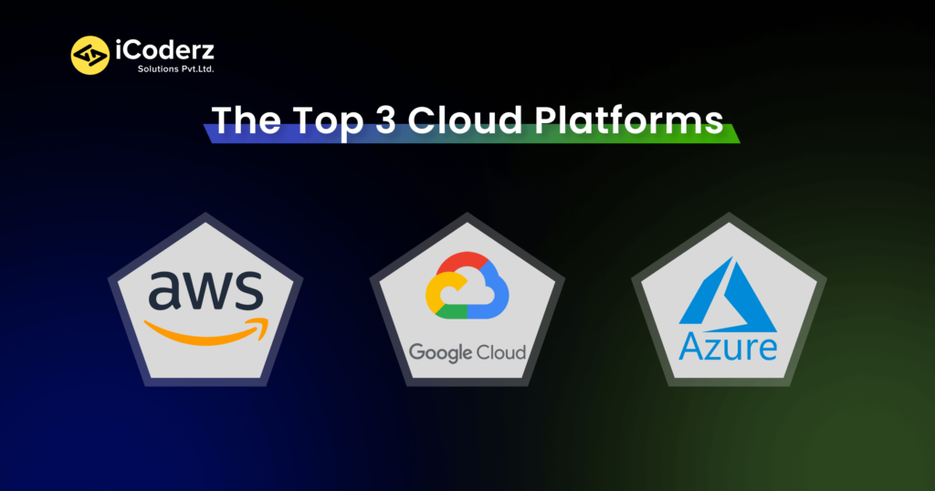
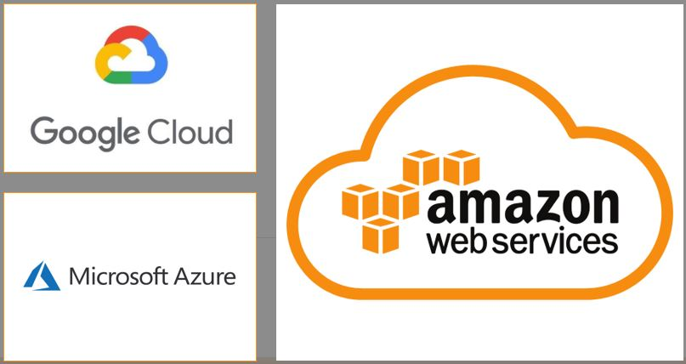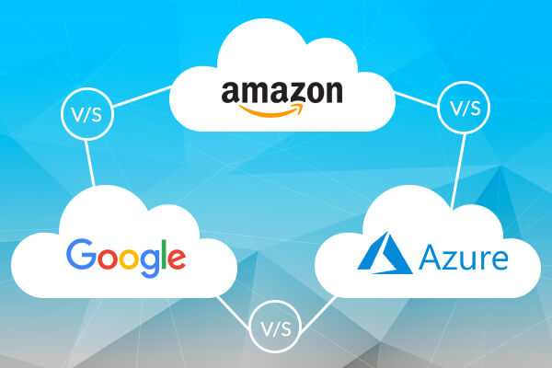
History and Market Presence
- Amazon Web Services (AWS) launched in 2006. It offered cloud computing to businesses as a pay-as-you-go service. It started with just a few basic services like storage and computation but quickly expanded.
- AWS is currently the leader in the cloud market. It holds a 33% market share.
- Microsoft Azure was introduced in 2010, initially called Windows Azure. It is the second-largest cloud provider. It aims to provide cloud services for computing, analytics, storage, and networking.
- Microsoft Azure follows closely behind with a 24% market share in cloud infrastructure.
- Google Cloud Platform (GCP) entered the market in 2011. While Google was running the search engine, its expansion was focused on large-scale computing solutions and data analytics.
- GCP holds an 11% market share. It's popular among companies that rely on analytics and machine learning.
Amazon Web Services (AWS)
Amazon Web Services (AWS) is the biggest cloud computing platform of all three. It offers computer resources and services that can construct applications in minutes at pay-as-you-go prices. For example, you can rent a server on AWS to connect to, configure, protect, and run just like a physical server. The distinction is that the virtual server runs on top of an AWS-managed planet-scale network.
Background: AWS became public in 2006, with services like Elastic Compute Cloud (EC2) and Simple Storage Service (Amazon S3). It has an extensive user base and higher levels of trust and reliability as one of the first cloud providers.
Region: AWS is divided into 22 geographic regions and 14 data centers. There are over 114 edge locations and 12 Regional Edge Caches.
Core Services:
- Elastic Compute Cloud (EC2) is a service that allows businesses to run virtual servers in the cloud.
- You can select the amount of computing power and memory needed for your applications.
- EC2 can scale up or down automatically, depending on your application. For example, you might need more power during busy hours and less at other times.
- It's suitable for small to large web applications that handle millions of users.
- AWS also offers database services. Amazon RDS is used for relational databases, DynamoDB for NoSQL solutions, and Redshift for data warehousing.
- Amazon RDS allows you to launch a database with just an API call. You don’t need to worry about the underlying database setup.
- DynamoDB can handle more than 10 trillion requests/day and can support peaks of 20 million requests/second.
- Redshift allows you to share your data across Redshift clusters and with other AWS accounts.
- AWS offers a suite of developer tools like AWS CodeBuild, CodeDeploy, and CodePipeline. These facilitate code integration and delivery.
- Amazon CloudFront is a fast CDN service that securely delivers media, data, and APIs to customers globally. It is done with low latency and high transfer speeds.
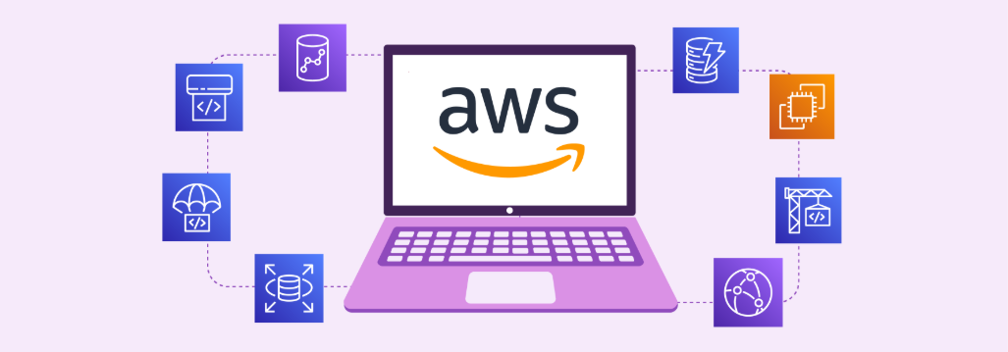

Notable users of Amazon Web Services (AWS)
- Coursera
- Netflix
- Formula 1
- Airbnb
- Coca Cola

Microsoft Azure
Microsoft Azure is a public cloud platform that provides infrastructure as a Service (IaaS), Platform as a Service (PaaS), and Software as a Service (SaaS) solutions for analytics, virtual computing, storage, networking, and other services. It can enhance or replace your on-premise servers.
Background: Microsoft Azure, known initially as Azure, was established in 2010 to provide enterprises with a capable Cloud Computing platform. In 2014, Azure was renamed 'Microsoft Azure,' though 'Azure' is still widely used.
Region: Microsoft Azure operates in 54 regions, each with at least three availability zones and 116 edge locations.
Core Services:
- Virtual Machines (VMs) in Azure are on-demand, scalable cloud computing resources. They are similar to physical desktops but hosted in Azure's cloud.
- Azure VMs offer the ability to scale your computational resources up or down.
- Azure CDN leverages Microsoft's global network to deliver content efficiently. It offers strong integration with Azure services.
- If your business uses Azure storage solutions, Azure CDN can automatically cache data and content from these services.
- Azure HDInsight is a cloud-based service that processes big data in real-time. It is used to analyze customer data and optimize operational decisions.
- Azure Cosmos DB provides a globally distributed, multi-model database service. It is used for managing data at scale.
- Azure offers developer tools like Visual Studio and Visual Studio Code integration. It makes it a favorite for Windows and .NET developers.
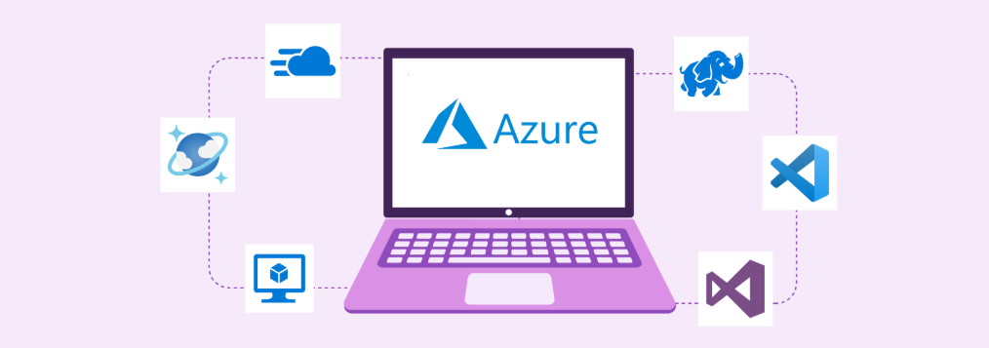

Notable users of Microsoft Azure
- Bosch
- Audi
- HSBC
- Starbucks
- Walmart
- HP
- Mitsubishi Electric
- Renault

Google Cloud Platform (GCP)
Google Cloud Platform (GCP)—often just called Google Cloud—was originally App Engine. It's a cloud computing services suite established by Google in 2008. GCP offers infrastructure as a service (IaaS), platform as a service (PaaS), and software as a service (SaaS) for businesses all around the world. GCP is primarily a service for developing and maintaining original applications that can then be published from its hyper-scale data centers.
Background: GCP launched in 2008 and, in less than a decade, has established a strong foothold in the cloud business. Google Cloud strengthened Google's products, including its hugely popular search engine and its video-sharing platform, YouTube.
Region: Google Cloud Platform comprises 34 cloud regions, 103 zones, and 200 plus edge locations.
Core Services:
- Compute Engine provides resizable compute capacity in the cloud. It allows you to spin up virtual machines as needed quickly.
- One of the standout features of Compute Engine is its ability to perform live migrations of Virtual Machines.
- If the hardware hosting your VM needs maintenance, Google can move your VM to another host without downtime.
- Google Cloud’s database services are Cloud SQL for relational databases, Firestore for NoSQL document storage, and BigQuery for data warehousing.
- GCP databases integrate well with advanced analytics, Google AI, and machine learning tools.
- Cloud SQL scales smoothly to store more data and handle more queries without managing the infrastructure.
- Firestore supports complex queries like filtering and sorting over multiple fields. It does this without lowering performance.
- BigQuery can process terabytes of data in seconds and petabytes in minutes. It integrates with Google’s data analytics and machine learning tools.
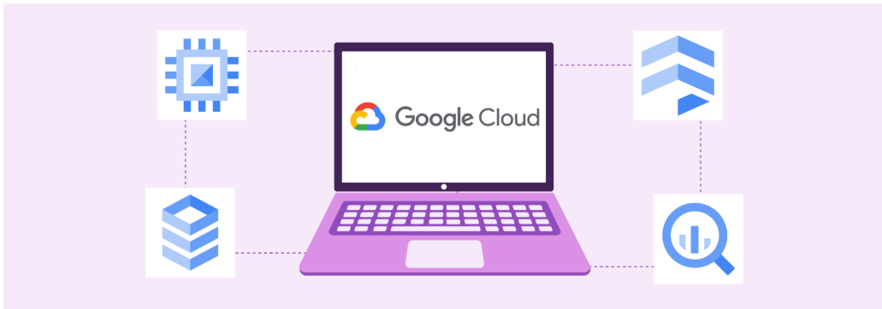

Notable users of Google Cloud Platform (GCP)
- Toyota
- Spotify
- Twitter(Currently X)
- Paypal

Benefits and considerations of AWS, Azure, and Google Cloud

Amazon Web Services
Pros
- Provides most services, from networking to robots.
- Considered the best for reliability and security
- More computational capacity than Azure and GCP
Cons
- All major software providers that make their applications available on AWS Dev/Enterprise support must be paid.
- The sheer quantity of services and options available can be overwhelming for newbies.
- There are relatively few hybrid cloud alternatives.

Microsoft Azure

Pros
- Integration and migration of current Microsoft services are simple.
- Many options are accessible, including best-in-class AI, machine learning, and analytics services.
- Most services are less expensive when compared to AWS and GCP.
- There is a lot of support for hybrid cloud strategies.
Cons
- Fewer service choices compared to AWS
- Specifically designed for business customers

Google Cloud Platform
Pros
- Works well with other Google services and products.
- Excellent containerized workload support
Cons
- Limited services compared to AWS and Azure Limited support for enterprise use cases

AWS vs. Azure vs GCP: Case Studies

Netflix

- Netflix uses Amazon Web Services for almost all its operational needs. It includes computing, storage, databases, analytics, and video transcoding.
- It is streamed across 192 countries simultaneously without performance issues.
- Netflix uses Amazon S3 services to store billions of data objects in its digital library. It includes movies and TV series that are highly durable.
- Amazon Kinesis enables Netflix to process and analyze large volumes of streaming data in real-time. It ensures data-driven decision-making.
- Netflix uses Amazon Recognition to analyze video content and provide personalized recommendations based on user viewing history.

Walmart

- Walmart uses Microsoft Azure to enhance its retail operations and customer service. It uses Azure’s machine learning and AI to understand customer preferences and optimize inventory.
- Services like Azure Data Lake help Walmart store and analyze petabyte-size files and trillions of objects.
- Walmart is building a global IoT platform on Azure for applications like connecting HVAC and refrigeration units in stores. It is to reduce energy usage and apply machine learning for supply chain routing.
- Walmart is also using large language models from Azure OpenAI Service, with its data, to power new AI features.
- Azure also provides the infrastructure to handle the massive amount of data generated by Walmart.

Twitter (Currently X)

- Twitter uses several GCP services to handle its massive data processing and performance.
- Google Cloud Pub/Sub provides real-time messaging services. It allows Twitter to distribute event data, such as tweets and notifications, efficiently.
- Twitter uses Tensorflow on Google Cloud AI for machine learning tasks. These include recommendations and content moderation.
- Twitter uses BigQuery as the anchoring service for the ingestion and extraction of valuable insights from its data. BigQuery enables Twitter to go from hypothesizing to action quickly.
- Twitter also uses Google Dataflow, a fully managed streaming analytics service. It is used to enhance productivity by reducing time spent on manual tasks for scaling.

